CPRS ENHANCEMENT PHASE 1
GMTS*2.7*120 Patch
Release Notes



AUGUST 2017

Department of Veterans Affairs
Office of Information & Technology (OI&T)
Product Development (PD)
Table of Contents
Table of Contents 2
Installation Requirements 3
Required Patches 3
Project Description 3
Patch Information 5
Release Method 6
New Functionality 6

Installation Requirements
Required Patches
Below is a list of patches that you must verify are properly installed on your system before CPRS EP1 GMTS*2.7*120 and its associated patches can be installed:
- GMTS*2.7*100
Project Description
Per the Joint Commission’s NPSG.03.06.01, a medication summary must be given to a patient upon each admission, discharge, or transfer. The document used currently is the Medication Reconciliation Tool #2 (MRT2), which is the reference for the patient-facing document. The MRT2 produced by VistA does not display non-VA medication information as thoroughly as it does VA medications. Even when all information is available, the MRT2 report does not present the Non-VA meds consistently. In fact, there is no 'worksheet space' available for the non-VA medications. Figure 1 shows an example of how MRT2 currently displays.

*********** CONFIDENTIAL Medication Worksheet SUMMARY pg. 1 ***********
BCMA,FIFTEEN-PATIENT 666-33-0015 DOB: 04/07/1935
3 NORTH GU

---------------- MWS - Medication Worksheet (Tool #2) -----------------

Date: Jul 24, 2017 PATIENT MEDICATION INFORMATION Page: 1
PRINTED BY THE VA MEDICAL CENTER AT: CAMP MASTER
FOR PRESCRIPTION REFILLS CALL (518) 472-4307

Name: BCMA,FIFTEEN-PATIENT PHARMACY - ALBANY DIVISION

|---------------------------------------------------------------------|
| |MORNING| NOON |EVENING|BEDTIME| COMMENTS |
|~~~~~~~~~~~~~~~~~~~~~~~~~~~~~~~~~~~~~~~~~~~~~~~~~~~~~~~~~~~~~~~~~~~~~|
| |
|**PENDING** ACARBOSE 25MG TAB |
| TAKE ONE TABLET BY MOUTH 3XW |
| Quantity: 5 Refills: 0 |
|---------------------------------------------------------------------|

|~~~~~~~~~~~~~~~~~~~~~~~~~~~~~~~~~~~~~~~~~~~~~~~~~~~~~~~~~~~~~~~~~~~~~|
| |
|**PENDING** ACETAMINOPHEN 325MG |
| TAKE ONE TABLET BY MOUTH EVERY 4 HOURS AS NEEDED |
| Quantity: 180 Refills: 0 |
|---------------------------------------------------------------------|
| UNITS PER DOSE: | | | | | |
|~~~~~~~~~~~~~~~~~~~~~~~~~~~~~~~~~~~~~~~~~~~~~~~~~~~~~~~~~~~~~~~~~~~~~|
| |
|**NON-VA** ACARBOSE 25MG TAB |
| TAKE ONE TABLET BY MOUTH 3ID Do not take medication when |
| consuming alcohol. Take with a full glass of water only. Take on|
| a full stomach. Do not mix with aspirin. Contact your provider |
| if you experience dizziness, excessive thirst, or hunger. |
|---------------------------------------------------------------------|
| UNITS PER DOSE: | | | | | |
|---------------------------------------------------------------------|

Any medication items listed as "pending" are those that have just been written by your provider(s). These medication orders will be reviewed by your pharmacist, prior to the prescription(s) being dispensed. When you receive your new prescription(s), by mail or from the pharmacy window, be sure to follow the instructions on the prescription label. If you have any question about your medication, please call your provider or your pharmacist.

Any medication items listed as "NON-VA" are Medications you do not get from a VA pharmacy that your provider recorded in your medical record. This includes medication prescribed by VA or non-VA providers, over the counter medications, herbals, samples or other medications you take.
Figure 1. Example of How MRT2 Currently Displays

Patch GMTS*2.7*120 removes the inconsistencies in the display on the patient-facing report generated from the Health Summary data and given to the patient when admitted, discharged, or transferred.
The screenshot below shows an example of a new and improved ‘NON-VA’ medication. It now has any entered comments listed with the medication.
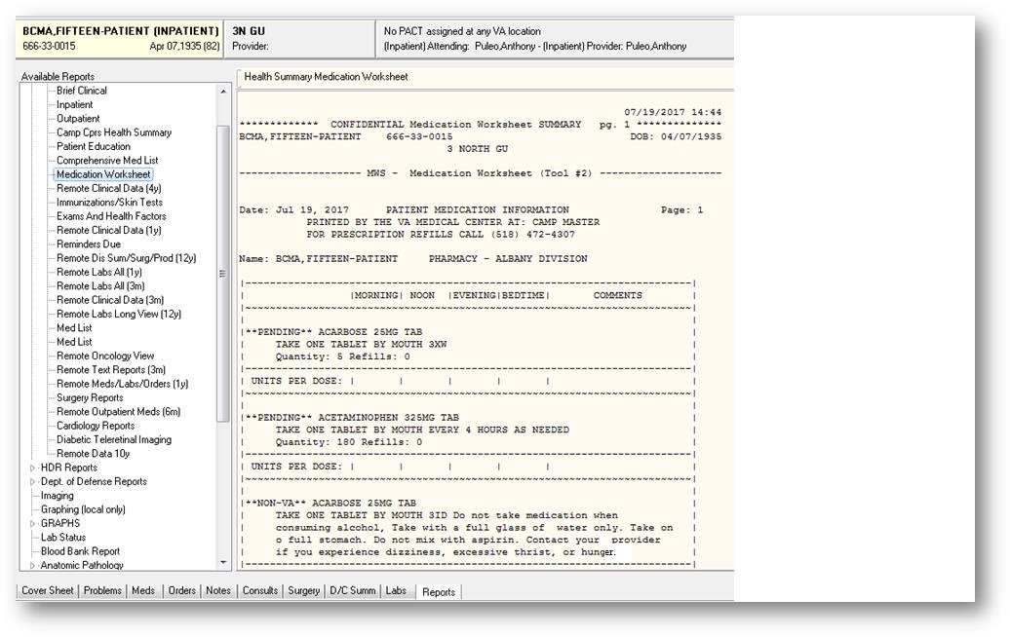
Figure 2. Example of New and Improved Non-VA Medication
The VA staff, which is responsible for medication review and counseling, does not have the ability to manage all aspects of medication order fulfillment. This could result in the patient being unaware of the correct medication, dosage, route, and schedule.
One of the challenges is that non-VA medication orders are not required to have all the same information as a VA prescribed medication. This enhancement does not address that issue. No new data is required due to this enhancement.
With this enhancement, the person reviewing the Medication Worksheet will have the ability to generate a complete patient-facing report using health summary information to provide medication, dosage, route, and schedule details about documented non-VA medications, when available, so that a comprehensive printout to patients for use during medication counseling. See Figure 3 for an example of a complete patient-facing report using health summary information.

************* CONFIDENTIAL Medication Worksheet SUMMARY pg. 1 **************
CPRSPATIENT,EIGHTYONE 666-06-1015 DOB: 04/15/1953

------------------------- MRT2 - Medication Worksheet -------------------------

Date: Nov 29, 2016 PATIENT MEDICATION INFORMATION Page: 1
PRINTED BY THE VA MEDICAL CENTER AT: CAMP MASTER
FOR PRESCRIPTION REFILLS CALL (518) 472-4307

Name: CPRSPATIENT,EIGHTYONE PHARMACY - ALBANY DIVISION

|-------------------------------------------------------------------------|
| |MORNING| NOON |EVENING|BEDTIME| COMMENTS |
|~~~~~~~~~~~~~~~~~~~~~~~~~~~~~~~~~~~~~~~~~~~~~~~~~~~~~~~~~~~~~~~~~~~~~~~~~|
| |
|**NON-VA** ABACAVIR SULFATE 300MG TAB |
| TAKE ONE TABLET BY MOUTH |
|-------------------------------------------------------------------------|
| UNITS PER DOSE: | | | | | |
|~~~~~~~~~~~~~~~~~~~~~~~~~~~~~~~~~~~~~~~~~~~~~~~~~~~~~~~~~~~~~~~~~~~~~~~~~|
| |
|**NON-VA** BOSENTAN 62.5MG TAB |
| TAKE ONE TABLET BY MOUTH TWICE A DAY Patient wants to buy from |
| Non-VA pharmacy. |
|-------------------------------------------------------------------------|
| UNITS PER DOSE: | | | | | |
|~~~~~~~~~~~~~~~~~~~~~~~~~~~~~~~~~~~~~~~~~~~~~~~~~~~~~~~~~~~~~~~~~~~~~~~~~|
| |
|**NON-VA** DRONABINOL CAP,ORAL |
| TAKE 1.9MG BY MOUTH |
|-------------------------------------------------------------------------|
| UNITS PER DOSE: | | | | | |
|~~~~~~~~~~~~~~~~~~~~~~~~~~~~~~~~~~~~~~~~~~~~~~~~~~~~~~~~~~~~~~~~~~~~~~~~~|
| |
|**PENDING** ACARBOSE 100MG TAB |
| TAKE TWO TABLETS BY MOUTH TWICE A DAY |
| Quantity: 120 Refills: 0 |
|-------------------------------------------------------------------------|
| UNITS PER DOSE: | | | | | |
|~~~~~~~~~~~~~~~~~~~~~~~~~~~~~~~~~~~~~~~~~~~~~~~~~~~~~~~~~~~~~~~~~~~~~~~~~|
| |
|**PENDING** ALENDRONATE 35MG TAB |
| TAKE ONE TABLET BY MOUTH TWICE A DAY |
| Quantity: 60 Refills: 0 |
|-------------------------------------------------------------------------|
| UNITS PER DOSE: | | | | | |
|~~~~~~~~~~~~~~~~~~~~~~~~~~~~~~~~~~~~~~~~~~~~~~~~~~~~~~~~~~~~~~~~~~~~~~~~~|
| |
|**PENDING** AMINO ACIDS 5.4% INJ |
| AMINO ACIDS 5.4% INJ 250 ml IM 120 ml/hr |
|-------------------------------------------------------------------------|
| UNITS PER DOSE: | | | | | |
|~~~~~~~~~~~~~~~~~~~~~~~~~~~~~~~~~~~~~~~~~~~~~~~~~~~~~~~~~~~~~~~~~~~~~~~~~|

Date: Nov 29, 2016 PATIENT MEDICATION INFORMATION Page: 2
PRINTED BY THE VA MEDICAL CENTER AT: CAMP MASTER
FOR PRESCRIPTION REFILLS CALL (518) 472-4307

Name: CPRSPATIENT,EIGHTYONE PHARMACY - ALBANY DIVISION

|-------------------------------------------------------------------------|
| |MORNING| NOON |EVENING|BEDTIME| COMMENTS |
|~~~~~~~~~~~~~~~~~~~~~~~~~~~~~~~~~~~~~~~~~~~~~~~~~~~~~~~~~~~~~~~~~~~~~~~~~|
| |
|LISINOPRIL 10MG TAB |
| TAKE ONE TABLET BY MOUTH TWICE A DAY |
| 0 refill(s) remaining prior to Jan 04, 2017 (Rx #58) |
|-------------------------------------------------------------------------|
| UNITS PER DOSE: | | | | | |
|~~~~~~~~~~~~~~~~~~~~~~~~~~~~~~~~~~~~~~~~~~~~~~~~~~~~~~~~~~~~~~~~~~~~~~~~~|
| |
|SUPPLY ITEMS: |
|ADHESIVE REMOVER LIQUID
|HEMATEST TAB (NOT FOR ORAL USE) |
|~~~~~~~~~~~~~~~~~~~~~~~~~~~~~~~~~~~~~~~~~~~~~~~~~~~~~~~~~~~~~~~~~~~~~~~~~|

Any medication items listed as "pending" are those that have just been
written by your provider(s). These medication orders will be reviewed
by your pharmacist, prior to the prescription(s) being dispensed. When
you receive your new prescription(s), by mail or from the pharmacy window,
be sure to follow the instructions on the prescription label. If you
have any question about your medication, please call your provider or
your pharmacist.

Any medication items listed as "NON-VA" are Medications you do not get
from a VA pharmacy that your provider recorded in your medical record.
This includes medication prescribed by VA or non VA providers, over the
counter medications, herbals, samples or other medications you take.
*** END ***** CONFIDENTIAL Medication Worksheet SUMMARY pg. 1 *************
Figure 3. Complete Patient-Facing Report Using Health Summary Information

Patch Information
- GMTS*2.7*120 provides an enhancement to the Medication Reconciliation Worksheet (MRT Tool #2) so it will be capable of displaying non-VA medication information in the same way that VA medication information is displayed on the patient-facing report. This report is generated from Health Summary data and given to a patient when admitted, discharged, or transferred.

